**Unit 1**

**Q.1) Create an application to demonstrate Node.js Modules.**

**Hello World Program**

console.log("Hello World, I'm batman");

console.error("This is not correct");

Output :

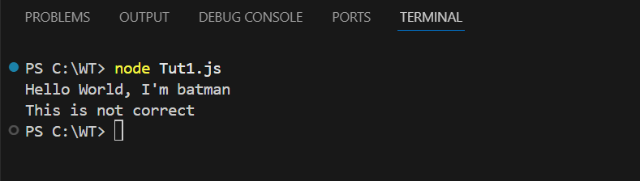

**Functions**

function myfun(num1,num2)

{

console.log(num1+num2);

console.log(num1-num2);

console.log(num1*num2);

console.log(num1/num2);

}

myfun(12,3);

Output :

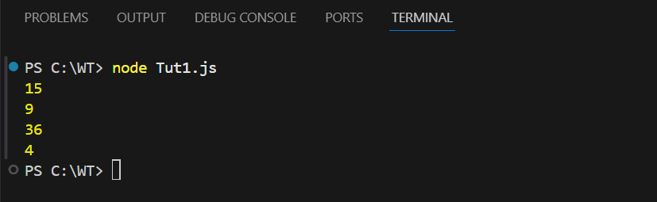

function myfun(x,y)

{

   return x*y;

}

console.log(myfun(5,5));

Output :

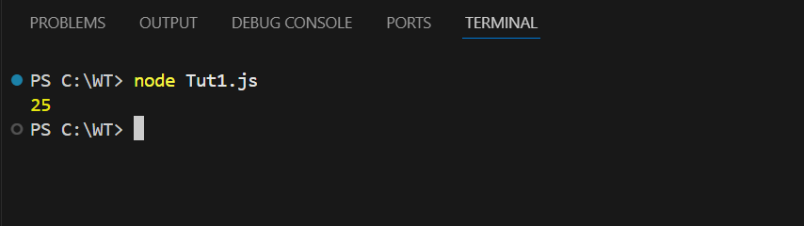

**Continuation passing cycle**

function displayresult(some)

{

 console.log(some);

}

function multiply(x,y,callback)

{

 let z=x*y;

 callback(z);

}

multiply(3,5,displayresult)

Output :

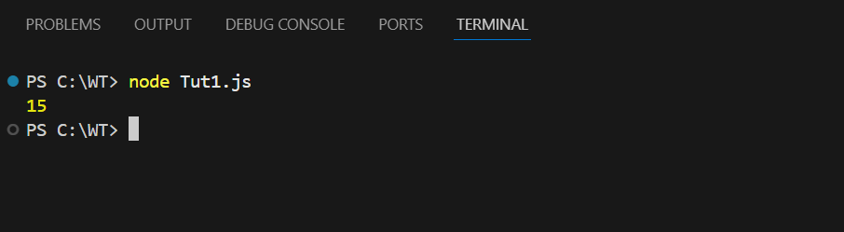

**Creating our own module**

Ownmodule.js

exports.myDateTime=function()

{

    return Date();

}

Tut1.js

var dt=require('./ownmodule');

console.log(dt.myDateTime());

Output :

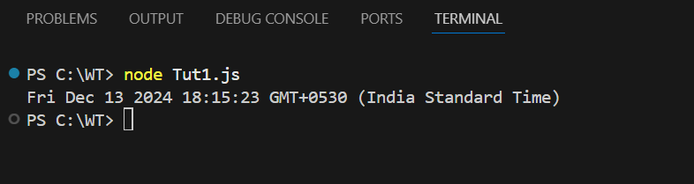

**Blocking code**

var fs=require('fs');

var data=fs.readFileSync('input.txt');

console.log(data.toString());

console.log("Program Ended");

Output :

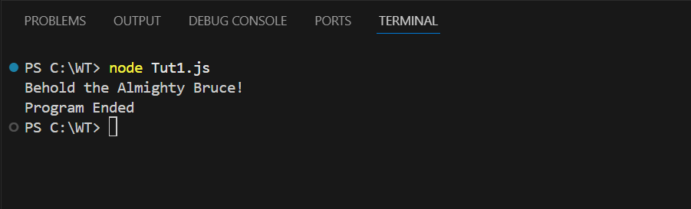

**Non-Blocking Code**

var fs=require('fs');

fs.readFile('input.txt',function(err,data){

    if(err)

    {

        return console.error(err);

    }

    console.log(data.toString());

});

console.log("program ended");

Output :

